Essay UTS Big Data
Name: Wilbert Chandra
NIM: 2602113666
Cloud Concept
- The pay-as-you-go (PAYG) pricing concept is a flexible pricing model that allows user to access technology services, and only pay for the computing resources that they use with little to no overhead cost. This model also relieves the burden of upfront investment and maintenance of idle infrastructure. The advantages of this model over the traditional infrastructure model are:
  - Cost Flexibility: PAYG allows businesses to align cost with usage, which is ideal for startups, small business, and projects with varying workloads.
  - Scalability: Businesses can easily scale up or down based on demand. For example, during peak times (Black Friday or Christmas), businesses can increase server capacity, and during slower periods, you can scale down to lower costs.
  - No Infrastructure Maintenance: The cloud provider manages the infrastructure, with the user never having to think about the infrastructure and only on how to optimize its usage.
  - Lower Barrier to Entry: PAYG eliminates the substantial cost of entry to build your own infrastructure.
The disadvantage of this model over the traditional infrastructure model are:
- Potentially Higher Costs: PAYG is cost-effective when the workloads are inconsistent of variable, which can make it more expensive for consistent workload than reserved instances. But for highly consistent workload maybe reserved instances is better.
- Lack or Predictability: PAYG cost can fluctuate at any time making it hard for businesses to predict the budgeting for it.
- Risk of Overspending: Without careful monitoring it’s possible to overspend on unoptimized resources.
- Definition of Infrastructure as a Service (IaaS), Platform as a Service (PaaS), and Software as a Service (SaaS) are:
  - IaaS: Service where provider delivers on-demand infrastructure to the user, where the user is in control of the infrastructure itself, making the user responsible for the OS, middleware, VM, and any apps or data that’s used but also giving the most flexibility to the user. Examples being Amazon EC2, Google Compute Engine, Microsoft Azure Virtual Machines.
  - PaaS: Service where all the hardware and software resources are managed by the provider, with the user only needing to code the program or application itself, without needing to worry about the underlying infrastructure. Examples being Heroku, AWS Elastic Beanstalk, AWS Lambda.
  - SaaS: Service where the user is provided with access to an application without needing to worry about the installation, setup and running the application. The user just needs to pay to use the application. Examples are Google Drive, Microsoft Office 365, OneDrive.
AWS Infrastructure and Security
- The 4 essential components of AWS Identity and Access Management and how they work together to enforce least privilege are:
  - Users: Individual people or entities who need access to AWS Resources. Users are assigned unique credentials to authenticate themselves when interacting with AWS services and can be grouped into IAM groups for easier management.
  - Groups: Collection of IAM users with similar permissions. Groups make it easier to manage users by assigning groups permissions that’s applicable to all users in the specific groups.
  - Roles: Role of a trusted entities (AWS Services) that allows for temporary access to resources without long-term credential. Roles are often used for cross-account access or granting permissions to AWS services.
  - Polices: JSON documents that define permissions. Policies are attached to users, groups, or roles that specify which actions are allowed or denied for specific resources.
All 4 components work together to enforce least privilege by carefully crafting IAM policies which will be assigned to users, groups, or roles based on their needs but no more than what they needed. With careful and precise assignment of polices to users, groups, and roles, we can ensure that no entity or instances have more permissions or access than needed.
- The concepts of high availability and fault tolerance in cloud computing, and how they work together are:
  - High Availability: System’s ability to keep functioning and operating for users even when certain components fail or go down. This ensures that critical applications and services are online as much as possible. High Availability can be achieved by keeping crucial data redundancy, server load balancing, failover mechanisms, and quick recovery.
  - Fault Tolerance: System’s ability to keep functioning even when specific components fail. Fault tolerance differs from high availability by its method of eliminating downtime by seamlessly switching to redundant components entirely. This approach involves redundant hardware, software, and automated failover mechanisms.
The 2 mechanisms can work together by complimenting each other roles such as, maintaining High availability when experiencing minor failures such as server crash, and using Fault Tolerance to ensure uninterrupted and seamless operation during major failures such as complete server room outage.
AWS Service Concept
- Definition for each of the following AWS services are:
  - VPC Peering: Service to connect 2 separate VPC in the same AWS region, which enable direct communication between instances in different VPCs.
  - Amazon Machine Image (AMI): Pre-configurate template for OS, Application Software, and all the necessary configurations which serve as the bases of EC2 Instances.
  - Security Group: Virtual firewall for EC2 instances that controls inbound and outbound traffic by specifying allowed rules (protocols, ports, and IP ranges).
  - Serverless Computation: Ability to tun code without provisioning or managing servers.
  - Snapshot: Point-in-time copy of an EBS Volumes which captures the data and configuration of the volume.
  - S3 Lifecycle Policy: Automation of the transition of object between storage classes (Standard to Infrequent Access to Glacier).
  - Read Replica: Copies of a source RDS instance, which allow for read-heavy workloads to offload read queries from primary database.
Automatic Scaling, Monitoring, and Billing Mechanism
- Elastic Load Balancing service in AWS are AWS service to distributes incoming applications traffic across multiple targets and virtual appliances in 1 or more Availability Zones. The use cases for each type are:
  - Application Load Balancers: Is used when decisions are made related to HTTP and HTTPS traffic routing and support path and host-based routing. With it working at the Application Layer of the OSI Model. Use Case: Web App, Microservices, and WebSocket.
  - Network Load Balancers: Works at the TCP/SSL of the OSI model. With its capability of handling millions of requests per second. Mainly used for load-balancing TCP Traffic. Use Case: Static IP Addresses and TCP/UDP Services.
  - Gateway Load Balancers: Providing the facility to deploy, scale, and manage virtual appliances like firewalls. With it combining transparent network gateway and distribute the traffic. Use Case: Hybrid Cloud and Transit Gateway.
- The concept of TCO in the cloud involves calculating the host, running, integrating, secure, and maintaining the workload in the cloud. This includes all fees that are associated with the infrastructure such as the cost of compute, storage, and data transfer. Manpower cost for cloud or data engineer is also included in TCO. We can calculate TCO in AWS by focusing on 3 main components: Compute, Storage, and Data Transfer:
  - Compute: All computation power is charged per hour by AWS, with more powerful compute instances having higher per-hour-cost. We can also make reserved instance to create not only cheaper per-hour cost but also predetermined compute power and cost.
  - Storage: AWS charge storage cost per-GB with several storage classes and type to choose based on the needed use cases and data types, of course with varying cost per GB. This makes choosing the most suitable storage type for the user use case and data types crucial to optimize TCO.
  - Data Transfer: AWS only charges for Data Transfer Out with it charging per-GB. But AWS does not charge for data transfer in or data transfer inter-service within a region.
AWS also has a feature that makes you save more if you reserve the services before, also make you save more (on-average) when you use more.

Cloud Architecture
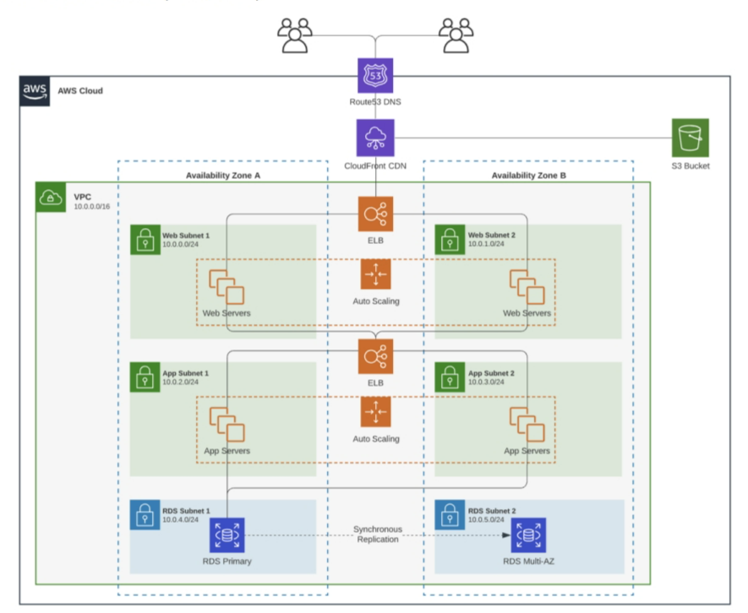
- Analyze the cloud architecture in picture 1 and explain the role of each component :
  - Route53 DNS: DNS (Domain Routing System) provided by AWS to route your traffic using domain names and routing policies. In the picture above its connected to CloudFront CDN (Routing CloudFront CDN Public IP to Domain Names)
  - VPC: Virtual Private Cloud that acts like a virtual network that’s dedicated to your account. It provides a layer of security and isolation for the application. VPC can be configured with your own IP address range, subnet for each tier of the service, and security groups for inbound and outbound traffic.
  - CloudFront CDN: A content delivery network that caches static content to ensure a faster and seamless experience.
  - S3 Bucket: A simple and scalable storage solution that’s highly scalable and durable for various data types (Image, Docs, Videos, and more). On this case it’s use as a cache storage for CloudFront CDN.
  - Availability Zones: Distinct location within a region. AZ can be interpreted as the presence of AWS datacenter in each region, with its own hardware, network, and more. AZs are used to increase fault tolerance and lower latency by ensuring that the services are not concentrated in 1 specific region.
  - Web Subnet: Subnet that contains the used web servers for the application.
  - App Subnet: Subnet that contains the used App servers for the application.
  - Web/App Server (EC2 Instance): A compute instance that run the web servers and the app servers.
  - ELB (Elastic Load Balancers): A service provided by AWS to distribute incoming traffic to multiple instances. On this case it distributes to multiple web servers’ instance and multiple app servers’ instance across 2 AZs.
  - Auto Scaling: A tool to automatically scale (increase or decrease) the number of instances based on the demand and predefined rules. This ensures that the application runs smoothly by keeping the right number of available resources to handle the traffic demand.
  - RDS (Relational Database Service): A database service that’s provided by AWS that’s used to easily set up, operate, and scale relational databases in the cloud. On this case it’s shown that we have 2 RDS, the 1st being RDS primary which is mostly used on normal case. and the 2nd being RDS Multi-AZ which is replicated from RDS Primary, presumably for backup.
  - Synchronous Application: A Method to keep the data in multiple RDS instance in multiple AZs synchronized in real time.

